SIMATS ENGINEERING
ASSESSMENT TOOL II — Visualization Analysis Report
Course: Data Handling and Visualization | Code: DSA06 | CO: CO5
Duration: 180 min | Total Marks: 100 | Reg No : 192524029  Name:KAILASH M

COURSE OUTCOME COVERED
CO5: Analyze and evaluate visualization choices to communicate patterns, comparisons, relationships, and potential misleading effects through appropriate visualization methods. (BL4)
Activity Tool : Visualization Analysis Report
Weightage: 20%
Code of Conduct:
I KAILASH M (192524029) certify that this submission is my original work and that I have adhered to the guidelines specified for this assessment. I understand that any violation of academic integrity rules will result in disciplinary action.
Signature of the student: KAILASH M

Assessment Criteria
Criteria | Visualization  Selection and  Understanding 25% | Visualization  Analysis and  Interpretation 25% | Application of Visualization Principles  20% | Organization and Presentation 20% | Accuracy  10% | Clarity  5% | Total
Q1
Q2
Q3
Q4
Q5

AT2 – Visualization Analysis Report | Data Handling and Visualization | DSA06
Visualization Analysis Report – Assessment Tool
R Programming Practical Questions with Datasets
Instructions: Answer all five questions. Use R programming to construct the required visualizations, analyze the patterns, compare visualization choices where requested, and identify potential visualization pitfalls. Use the given data exactly unless a transformation is explicitly requested.

Q1 — Comparing Distributions: Histogram, Density and ECDF
The question requires a histogram, density plot, and ECDF for the 20 processing-time observations, followed by a comparison of center, spread, skewness, and cumulative behavior.
# Q1: Comparing Distributions
# Histogram, Density Plot and ECDF

# Data
Time <- c(18, 21, 22, 24, 25, 25, 27, 28, 29, 30,
31, 32, 33, 35, 36, 38, 41, 43, 46, 50)

# -----------------------------------
# 1. Histogram
# -----------------------------------

hist(Time,
breaks = 8,
main = "Histogram of Processing Times",
xlab = "Processing Time (minutes)",
ylab = "Frequency")

# -----------------------------------
# 2. Density Plot
# -----------------------------------

plot(density(Time),
main = "Density Plot of Processing Times",
xlab = "Processing Time (minutes)",
ylab = "Density",
lwd = 2)

# -----------------------------------
# 3. ECDF
# -----------------------------------

plot(ecdf(Time),
main = "Empirical Cumulative Distribution Function",
xlab = "Processing Time (minutes)",
ylab = "Cumulative Probability",
verticals = TRUE,
do.points = TRUE)

grid()

Optional: All three using ggplot2
# Install if needed:
# install.packages("ggplot2")

library(ggplot2)

data <- data.frame(Time)

# Histogram
ggplot(data, aes(x = Time)) +
geom_histogram(bins = 8) +
labs(
title = "Histogram of Processing Times",
x = "Processing Time (minutes)",
y = "Frequency"
)

# Density plot
ggplot(data, aes(x = Time)) +
geom_density() +
labs(
title = "Density Plot of Processing Times",
x = "Processing Time (minutes)",
y = "Density"
)

# ECDF
ggplot(data, aes(x = Time)) +
stat_ecdf() +
labs(
title = "ECDF of Processing Times",
x = "Processing Time (minutes)",
y = "Cumulative Probability"
)

Interpretation
- Histogram: Clearly shows the frequency distribution and gives an overall view of the center and spread.
- Density plot: Provides a smoother representation of the distribution and makes shape and skewness easier to observe.
- ECDF: Shows the cumulative behavior directly—for example, the proportion of tasks completed below a particular processing time.
- The data have a moderate spread from 18 to 50 minutes and show some right-skewness because a few observations extend toward the higher processing times.
Conclusion: The histogram is best for frequency and overall distribution, the density plot is useful for identifying the shape/skewness, and the ECDF is best for understanding cumulative probabilities.

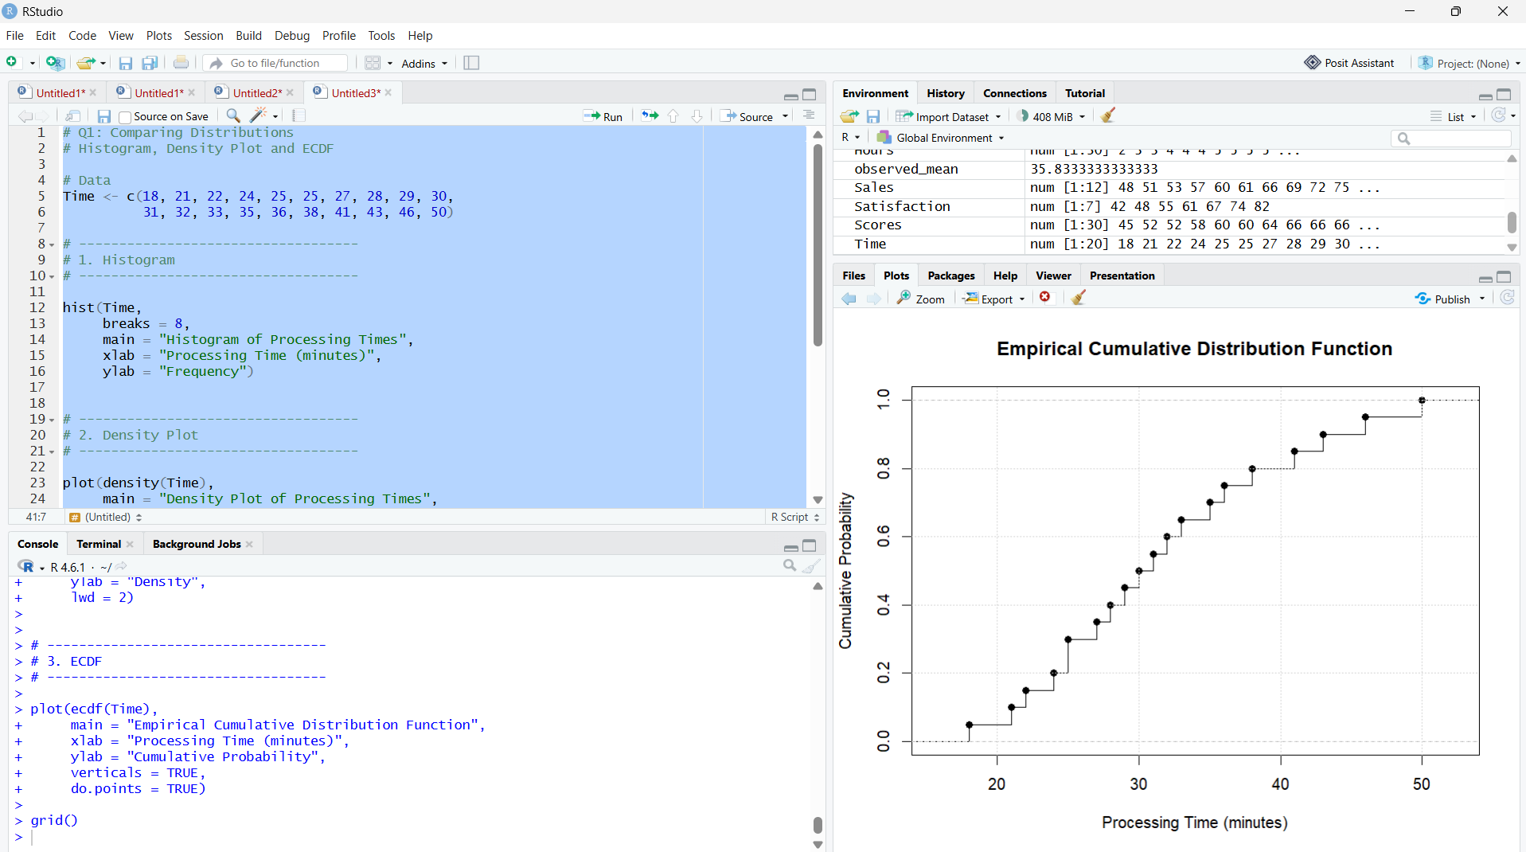

Q2 — Q-Q Plot and Normality Analysis
The question asks you to create a normal Q-Q plot and a histogram/density plot, then assess whether the response times are reasonably consistent with a normal distribution and identify deviations from the reference line.
# Q2: Q-Q Plot and Normality Analysis

# Data
Response <- c(42, 45, 47, 49, 50, 51, 52, 53, 54, 55,
56, 57, 58, 60, 61, 63, 66, 70, 76, 85)

# -----------------------------------
# 1. Normal Q-Q Plot
# -----------------------------------

qqnorm(Response,
main = "Normal Q-Q Plot of Response Times",
xlab = "Theoretical Quantiles",
ylab = "Sample Quantiles")

# Add reference line
qqline(Response,
lwd = 2)

# -----------------------------------
# 2. Histogram
# -----------------------------------

hist(Response,
breaks = 8,
main = "Histogram of Response Times",
xlab = "Response Time (seconds)",
ylab = "Frequency")

# -----------------------------------
# 3. Density Plot
# -----------------------------------

plot(density(Response),
main = "Density Plot of Response Times",
xlab = "Response Time (seconds)",
ylab = "Density",
lwd = 2)

Optional: Add a normality test
# Shapiro-Wilk normality test

shapiro.test(Response)

Interpretation
- Most observations should lie reasonably close to the Q-Q reference line if the data are approximately normally distributed.
- The higher response times, particularly 70, 76, and 85 seconds, show noticeable deviation from the reference line.
- The value 85 seconds is relatively far from the main group and may indicate a possible high-end outlier.
- The histogram and density plot also help reveal the longer upper tail.
Conclusion: The observations are approximately normal in the central region, but there is some departure from normality in the upper tail due to the larger response times.
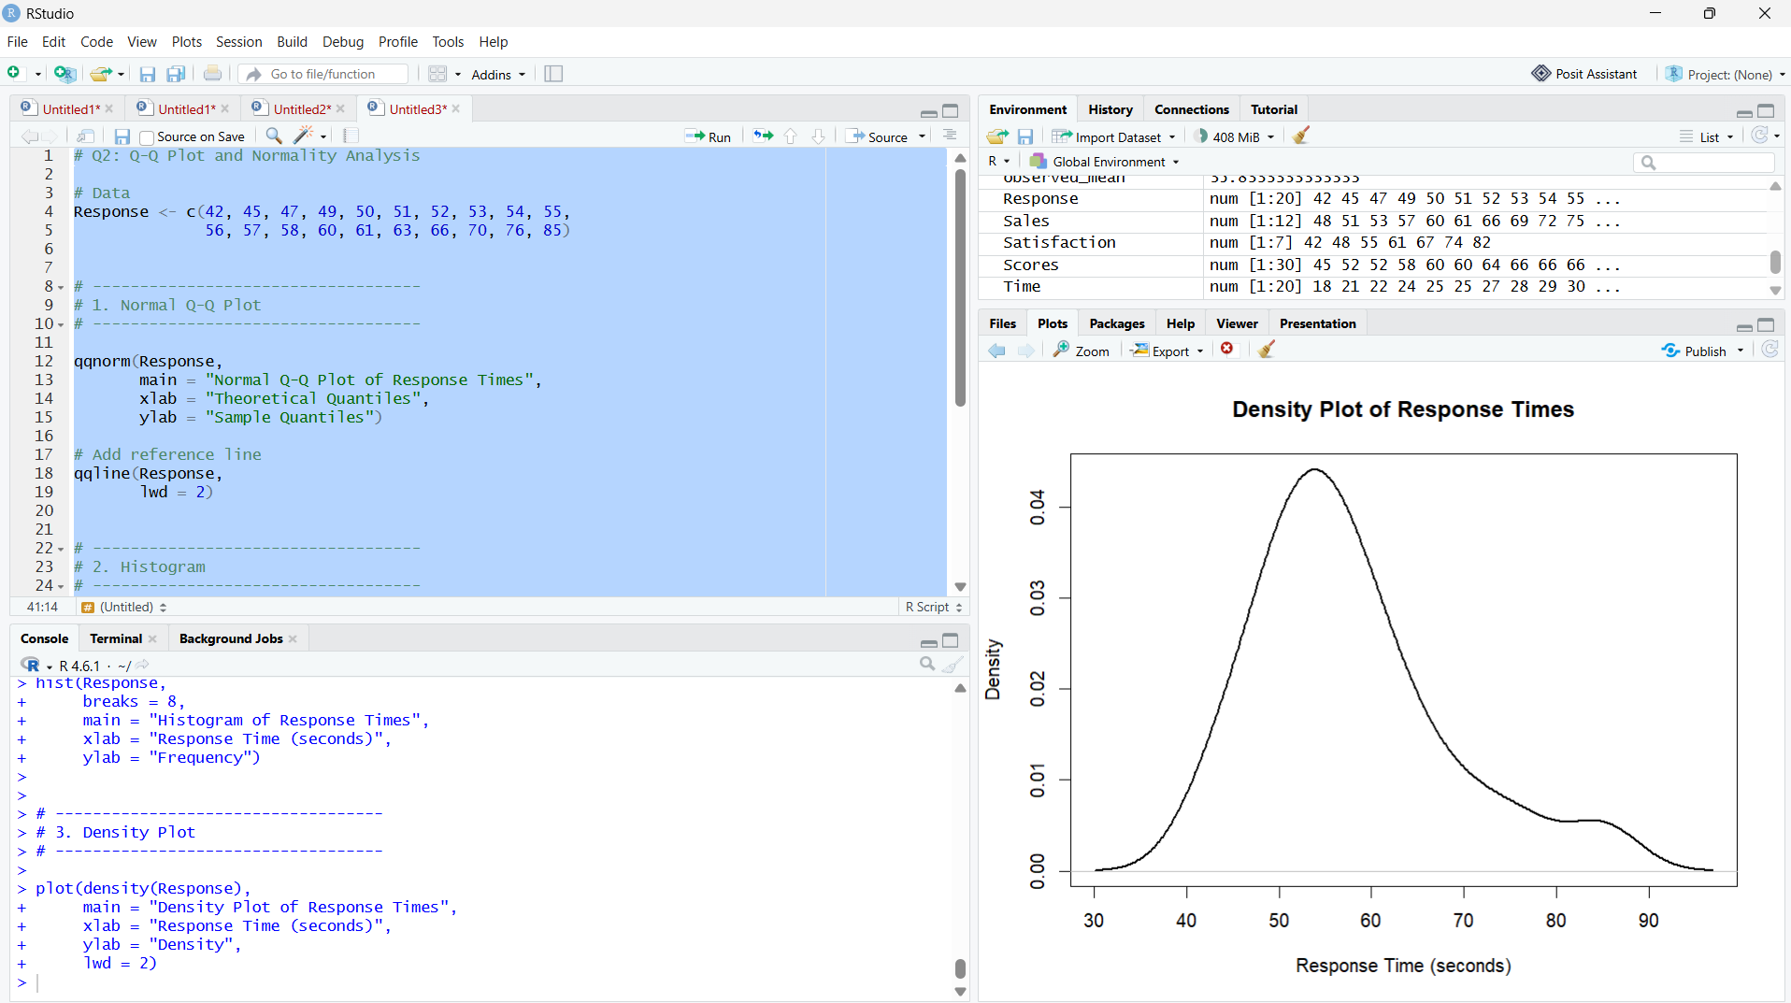

Q3 — Visualizing Many Distributions at Once
The question asks you to compare the distributions of Groups A, B, and C using boxplots and/or violin plots, optionally with individual observations, and analyze center, spread, and possible outliers.
# Q3: Visualizing Many Distributions at Once

# Load ggplot2
library(ggplot2)

# Data
Group_A <- c(52,55,57,58,60,61,62,64,65,66,68,70,72,74,78)

Group_B <- c(45,49,51,53,55,56,58,59,60,62,63,65,67,69,71)

Group_C <- c(58,60,61,63,64,65,67,68,70,71,72,74,76,80,84)

# Create data frame
data <- data.frame(
Score = c(Group_A, Group_B, Group_C),
Group = factor(
rep(c("Group A", "Group B", "Group C"),
each = 15)
)
)

# -----------------------------------
# 1. Boxplot with individual points
# -----------------------------------

ggplot(data, aes(x = Group, y = Score)) +
geom_boxplot() +
geom_jitter(width = 0.15, alpha = 0.6) +
labs(
title = "Examination Score Distribution by Group",
x = "Student Group",
y = "Examination Score"
)

# -----------------------------------
# 2. Violin Plot with individual points
# -----------------------------------

ggplot(data, aes(x = Group, y = Score)) +
geom_violin() +
geom_jitter(width = 0.15, alpha = 0.6) +
labs(
title = "Violin Plot of Examination Scores",
x = "Student Group",
y = "Examination Score"
)

Interpretation
- Group A: Has a relatively high center, with scores ranging from 52 to 78.
- Group B: Has the lowest center, with scores ranging from 45 to 71.
- Group C: Has the highest center and extends up to 84.
- The boxplot makes it easy to compare the median, spread, and possible outliers of all three groups at the same time.
- The jittered points show the individual student scores, making the distribution easier to inspect.
Conclusion: A grouped boxplot is more informative than three separate plots because all groups share the same scale and are positioned side-by-side, allowing direct comparison of their centers and spreads.
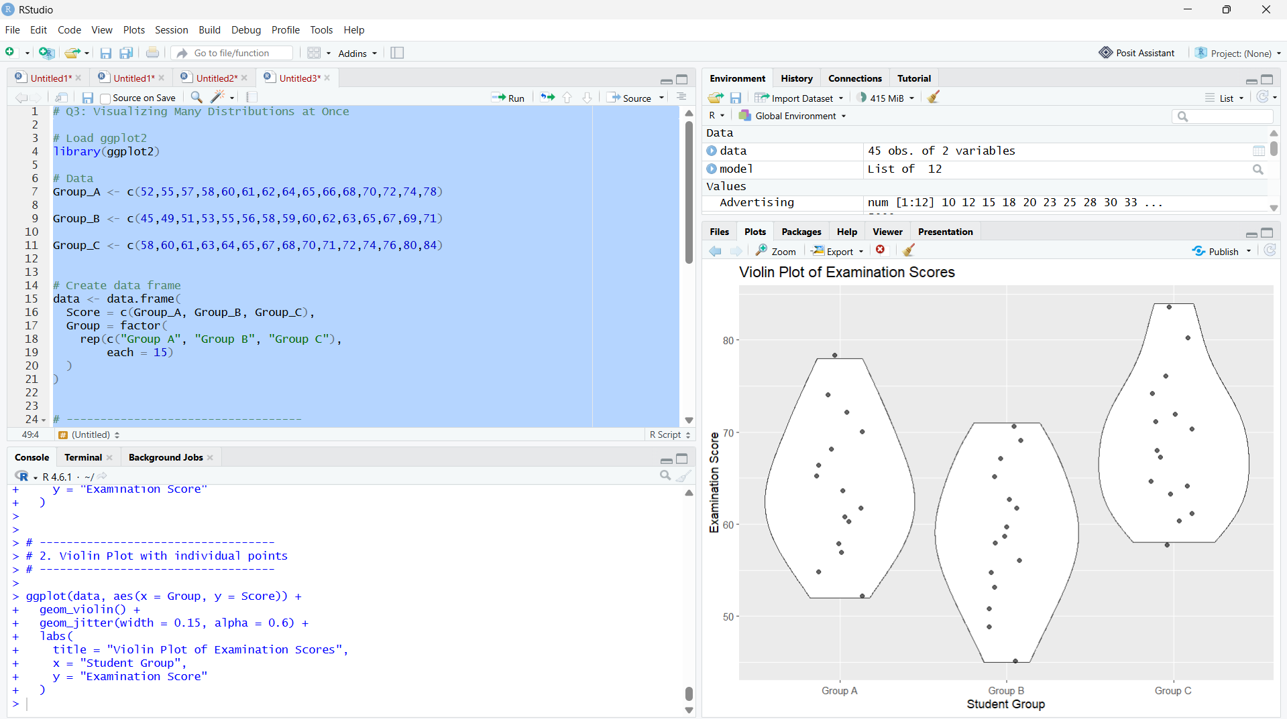

Q4 — Relationships and Multivariate Visualization
The question asks you to create a scatterplot of Advertising vs Sales, use Website Visits as an additional visual encoding, add a fitted trend line, and analyze whether the extra variable improves or clutters the visualization.
# Q4: Relationships and Multivariate Visualization

# Load ggplot2
library(ggplot2)

# Data
Advertising <- c(10,12,14,16,18,20,22,24,26,28,30,32,34,36,38)

Visits <- c(120,135,150,165,180,195,210,225,245,260,275,290,305,320,340)

Sales <- c(48,50,53,55,58,61,63,66,69,71,74,77,80,83,86)

# Create data frame
data <- data.frame(
Advertising,
Visits,
Sales
)

# -----------------------------------
# Scatterplot with Visits as Size
# -----------------------------------

ggplot(data, aes(x = Advertising,
y = Sales,
size = Visits)) +
geom_point(alpha = 0.7) +
geom_smooth(
method = "lm",
formula = y ~ x,
se = TRUE
) +
labs(
title = "Advertising Expenditure vs Sales",
x = "Advertising Expenditure",
y = "Sales",
size = "Website Visits"
)

Optional: Use color for Website Visits
ggplot(data, aes(x = Advertising,
y = Sales,
color = Visits)) +
geom_point(size = 3) +
geom_smooth(
method = "lm",
formula = y ~ x,
se = TRUE
) +
labs(
title = "Advertising Expenditure vs Sales",
x = "Advertising Expenditure",
y = "Sales",
color = "Website Visits"
)

Interpretation
- There is a strong positive relationship between advertising expenditure and sales.
- As Advertising increases, Sales also increase.
- Website visits also increase along with advertising expenditure.
- Encoding Website Visits using point size adds another variable without changing the main x-y relationship.
- However, adding too many visual encodings can create clutter and make the main relationship harder to understand.
Conclusion: The scatterplot with a fitted trend line clearly communicates the positive relationship between advertising and sales. Using point size for website visits adds useful information, but it should be kept simple to avoid visual clutter.
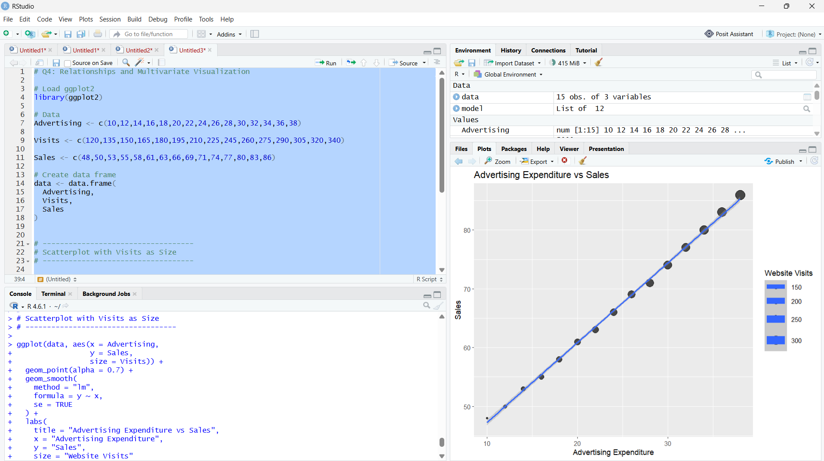

Q5 — Misleading Visualization and Redesign
The question asks for two bar charts: one misleading chart with a truncated y-axis and inappropriate visual emphasis, and one redesigned chart with a proper baseline, ordered categories, and clear labels.

R Code
# Q5: Misleading Visualization and Redesign

# Load ggplot2
library(ggplot2)

# Data
Department <- c("CSE", "ECE", "EEE", "MECH",
"CIVIL", "AIDS", "IT")

Pass_Percentage <- c(91, 93, 92, 89, 90, 95, 94)

# Create data frame
data <- data.frame(
Department,
Pass_Percentage
)

# -----------------------------------
# 1. Misleading Visualization
# -----------------------------------

ggplot(data, aes(x = Department,
y = Pass_Percentage,
fill = Department)) +
geom_col() +
coord_cartesian(ylim = c(88, 96)) +
labs(
title = "Misleading Pass Percentage Chart",
x = "Department",
y = "Pass Percentage (%)"
)

# -----------------------------------
# 2. Redesigned Visualization
# -----------------------------------

# Order departments by pass percentage
data$Department <- reorder(
data$Department,
data$Pass_Percentage
)

ggplot(data, aes(x = Department,
y = Pass_Percentage)) +
geom_col() +
coord_cartesian(ylim = c(0, 100)) +
geom_text(
aes(label = paste0(Pass_Percentage, "%")),
vjust = -0.3
) +
labs(
title = "Pass Percentage by Department",
x = "Department",
y = "Pass Percentage (%)"
)

Interpretation
Misleading chart:
- The y-axis starts at 88% instead of 0%.
- Because the differences are visually magnified, the chart can make small differences between departments appear much larger.
- Using different colors for every department adds unnecessary visual emphasis.
Redesigned chart:
- Uses a 0–100% baseline, which represents the percentage scale honestly.
- Departments are ordered by pass percentage.
- Percentage values are displayed directly above the bars.
- Clear labels make the comparison easier.
Conclusion: The redesigned visualization communicates the data more honestly because the differences between departments are shown in their proper proportion.
